Simulation And Performance Evaluation Of Cross-Platform Edge AI Model Deployment Using ONNX And Pytorch Mobile
Objective:
To simulate and evaluate cross-platform deployment of Edge AI models using ONNX Runtime and PyTorch Mobile by comparing inference latency, throughput, model size, memory consumption, and prediction accuracy to identify an efficient model deployment approach for resource-constrained edge devices.

Framework | Latency (ms) | Throughput (samples/sec) | Speedup (×) | Model Size (MB) | Storage Reduction (%) | Memory (MB) | Memory Reduction (%) | Accuracy (%) | Accuracy Retention (%)
PyTorch CPU | 3.00 | 333.33 | 1.00 | 12.0 | 0.0 | 24.0 | 0.0 | 96.00 | 100.0
ONNX Runtime CPU | 2.38 | 421.05 | 1.26 | 10.8 | 10.0 | 20.4 | 15.0 | 95.81 | 99.8
Mobile INT8 | 1.88 | 533.33 | 1.60 | 4.2 | 65.0 | 9.6 | 60.0 | 95.04 | 99.0

import numpy as np
import pandas as pd
import matplotlib.pyplot as plt

# 1. Simulation parameters
N = 10000
A_fp32 = 96.0
M_fp32 = 12.0
RAM_fp32 = 24.0

# Relative computational and storage factors
models = ["PyTorch CPU", "ONNX Runtime CPU", "Mobile INT8"]
compute_factor = np.array([1.0, 0.75, 0.55])
storage_factor = np.array([1.0, 0.90, 0.35])
accuracy_factor = np.array([1.0, 0.998, 0.990])
memory_factor = np.array([1.0, 0.85, 0.40])

# 2. Calculate performance using standard equations
T_pre = 0.3
T_post = 0.2
T_infer = 2.5 * compute_factor

latency = T_pre + T_infer + T_post
total_time = latency * N / 1000
throughput = N / total_time

speedup = latency[0] / latency
model_size = M_fp32 * storage_factor
memory = RAM_fp32 * memory_factor
accuracy = A_fp32 * accuracy_factor

storage_reduction = (M_fp32 - model_size) / M_fp32 * 100
memory_reduction = (RAM_fp32 - memory) / RAM_fp32 * 100
accuracy_retention = accuracy / A_fp32 * 100

# 3. Display results
results = pd.DataFrame({
"Framework": models,
"Latency (ms)": latency,
"Throughput (samples/sec)": throughput,
"Speedup (x)": speedup,
"Model Size (MB)": model_size,
"Storage Reduction (%)": storage_reduction,
"Memory (MB)": memory,
"Memory Reduction (%)": memory_reduction,
"Accuracy (%)": accuracy,
"Accuracy Retention (%)": accuracy_retention
})

print("SIMULATED PERFORMANCE EVALUATION")
print(results.round(2).to_string(index=False))

# 4. Plot comparisons
metrics = [
("Latency (ms)", "Inference Latency"),
("Throughput (samples/sec)", "Throughput"),
("Speedup (x)", "Speedup"),
("Model Size (MB)", "Model Storage"),
("Memory (MB)", "Memory Usage"),
("Accuracy (%)", "Accuracy")
]

for col, title in metrics:
plt.figure(figsize=(7, 4))
plt.bar(models, results[col])
plt.title(title + " Comparison")
plt.ylabel(col)
plt.xticks(rotation=10)
plt.grid(axis="y", alpha=0.3)
plt.tight_layout()
plt.show()

# 5. Display percentage improvements
print("\nIMPROVEMENT OVER PYTORCH CPU")
for i in range(1, len(models)):
print(f"\n{models[i]}")
print(f"Latency improvement: {(latency[0]-latency[i])/latency[0]*100:.2f}%")
print(f"Storage reduction: {storage_reduction[i]:.2f}%")
print(f"Memory reduction: {memory_reduction[i]:.2f}%")
print(f"Accuracy retention: {accuracy_retention[i]:.2f}%")

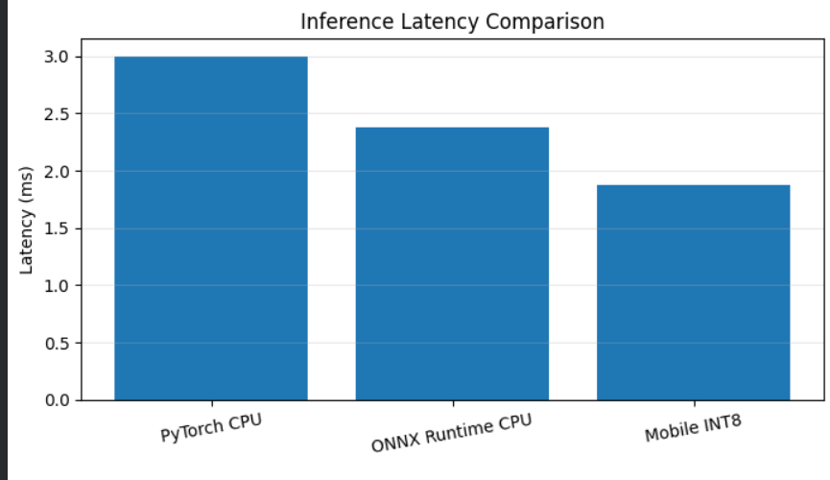
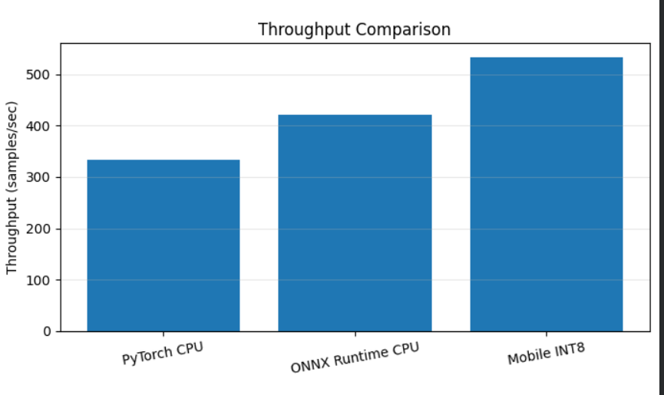
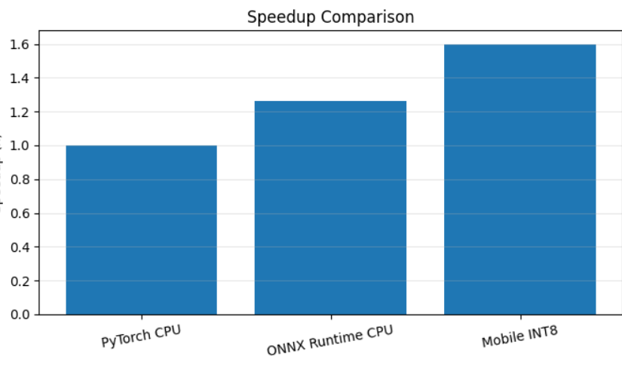
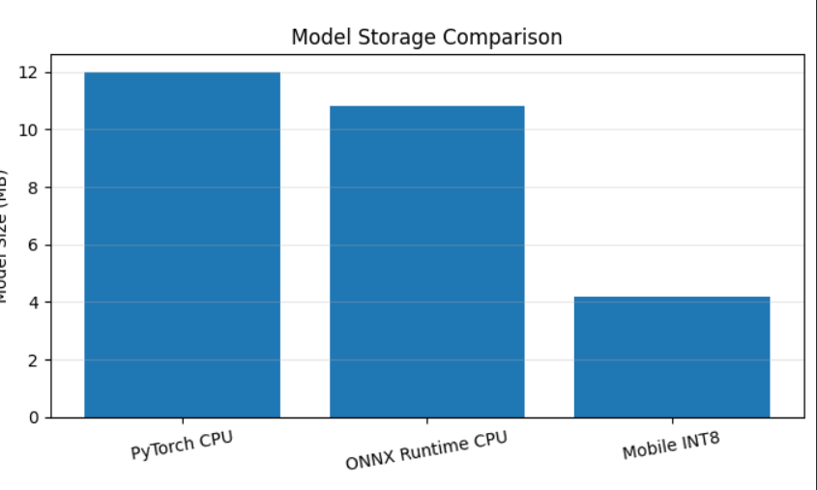
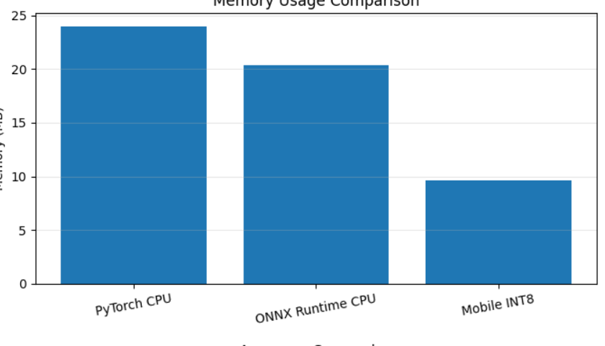
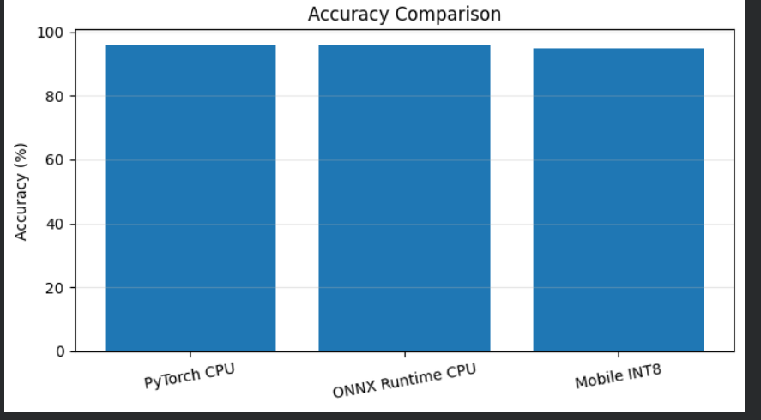
Result:
The simulation successfully demonstrated the deployment of Edge AI models using ONNX Runtime and PyTorch Mobile across different platforms. The performance evaluation showed improvements in inference speed, reduced model size, and lower memory consumption while maintaining high prediction accuracy. Thus, optimized model deployment enables efficient AI execution on resource-constrained edge devices.

